A000-Am,S-Colombia-Tairona-Tumnbaga- Cacique seated-1000-1400 CE

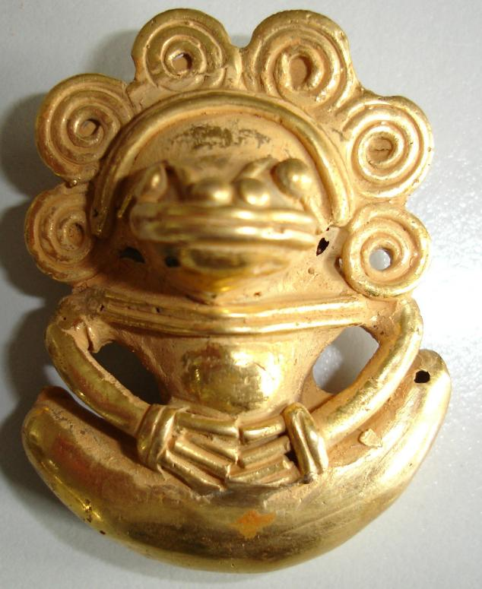

**Cacique** (Spanish: [[kaˈθike, kaˈsike]](http://en.wikipedia.org/wiki/Help:IPA_for_Spanish); Portuguese: [[kɐˈsikɨ, kaˈsiki]](http://en.wikipedia.org/wiki/Wikipedia:IPA_for_Portuguese_and_Galician); feminine form: *cacica*), also [**cassique**](http://en.wikipedia.org/wiki/Cassique) in archaic English, is a title derived from the [Taíno](http://en.wikipedia.org/wiki/Taíno_people) word for the [pre-Columbian](http://en.wikipedia.org/wiki/Pre-Columbian) [chiefs or leaders](http://en.wikipedia.org/wiki/Tribal_chief) of tribes in the [Bahamas](http://en.wikipedia.org/wiki/Bahamas), [Greater Antilles](http://en.wikipedia.org/wiki/Greater_Antilles), and the northern [Lesser Antilles](http://en.wikipedia.org/wiki/Lesser_Antilles). The Spanish, subsequent to encounters with the Taíno upon their arrival in the New World, used the word as a title for the leaders of the other indigenous tribes they encountered in the Western Hemisphere territories they occupied. In the Taíno culture, the cacique rank was apparently established through democratic means. His importance in the tribe was determined by the size of his tribe rather than his warlord skills, since the Taínos were mostly a pacifist culture. They also enjoyed several privileges for their standing: they lived in a larger rectangular hut in the center of the village and had a special sitting place for the *areytos* (ceremonial dances) and the ceremonial ball game.[[2]](http://en.wikipedia.org/wiki/Cacique" \l "cite_note-2)